Issue Tracking System

Abstract:

An issue tracking system is a computer software package that manages and maintains lists of issues. Issue tracking systems are generally used in collaborative settings, especially in large or distributed collaborations, but can also be employed by individuals as part of a time management. In this employees can post their issues and can search issues and bugs. This issues can be solved by respected department experts and developers

Various Models:

1. User
2. Department
3. Developers
4. Issues
5. Comments
6. Tracking
7. Bugs
8. Product
Description of Models:

1. User:

This table consists of all the employee’s data such as user_id, user_name, user_email, user_phone_no, user_dept_id, user_address, user_password.

2. Department:

This table consist of all the department data such as dept_id, dept_name, dept_description.

3. Developers:

This table consist of all the developers’s data such as developer_id , developer_name, developer_mobile_no, developer_email, developer_password, developer_username, developer_address.

4. Issues:

This table consists of all the issue data such as issue_id, issue_creator_id, issue_name, issue_description, issue_dept_id, issue_created_date, issue_status.

5. Comments:

This table consists of all comment of issues and consist columns such as comment_id, user_id, issue_id, dept_id, comment_date, comment_description.

6. Tracking:

This table consists of all the tracking details i.e. status of issues such as tracking_id, issue_id, issue_solver_id, issue_status, issue_status_description, issue_deadline.

7. Bugs:

This table consists of all the Bugs data such as bug_id, bug_creator_id, bug_name, bug_dept_id, bug_description.

8. Product:

This table consists of all the product’s details of orginazation such as product_id, product_description, product_name, product_dept_id, product_developer_id .

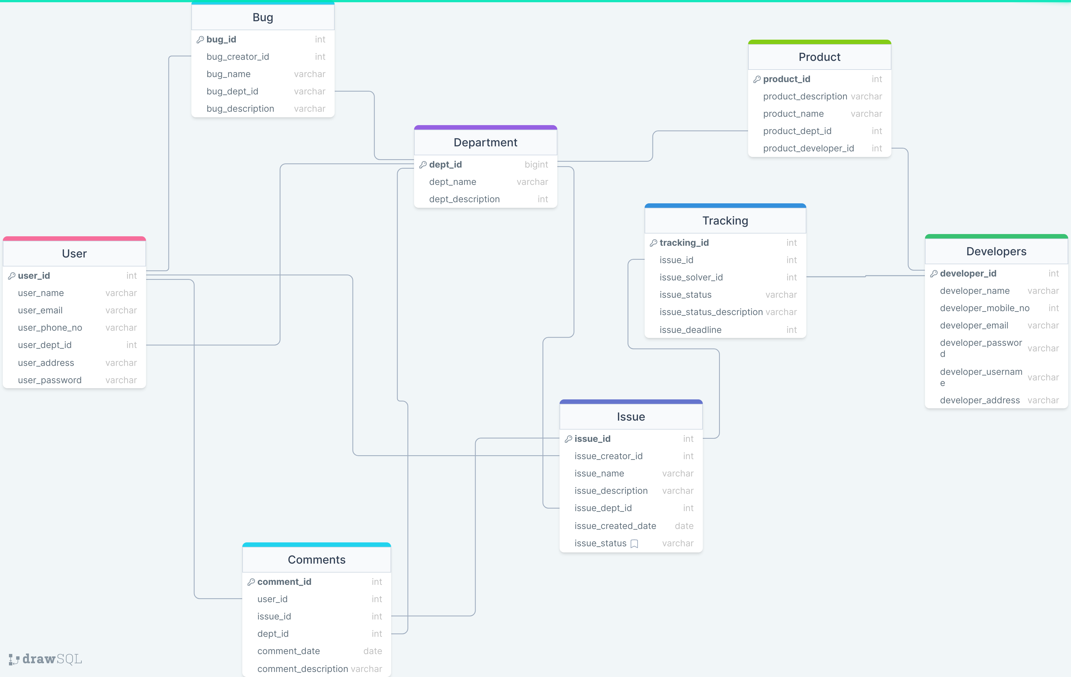
ER- Diagram

